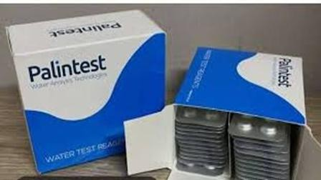
Chlorine tablets 0.33 mg

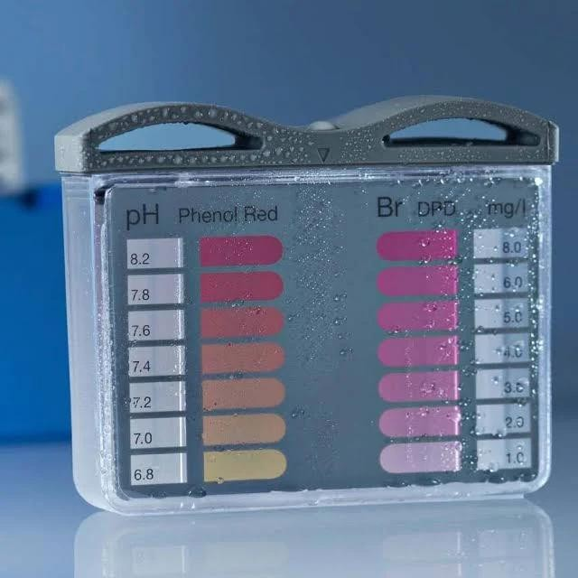
Lovibond 151605 Pool testers, Active Oxygen and pH

